Democratization: Learning from the Lessons of Others
9 September 2003, Passia Workshop, Ramallah
Country |  | Time |  | Speaker
Palestine |  | 10:00 11:00 |  | 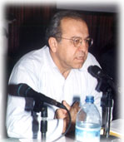  Democracy and Ethnic Tyranny: The Experience of Palestine Citizens in Israel  Dr. Nadim Rouhana, Director of MADA (Center for Applied Social Research), Haifa, Sociology lecturer, Tel Aviv University
Spain |  | 11:00  12:00 |  | 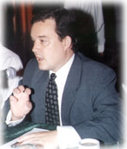  Spain’s Transition to Democracy: Reflections on the 25th Anniversary of the Spanish Constitution  Mr. Alberto Ucelay, Deputy Consul General, Spanish Consulate, Jerusalem  Read More
The Czech Republic |  | 12:30 13:30 |  | 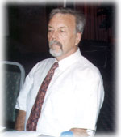  The Democratization Process in Post-Communist Czech Republic  Dr. Ladislav Venys, Director, Center for Democracy and Free  Enterprise, Prague,The Czech Republic  Read More
South Africa |  | 15:00 16:00 |  | 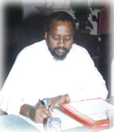  The South African Experience in the Democratization Process  Dr. Pallo Jordan, Member of the South African Parliament & African National Congress (ANC), Western Cape, South Africa

