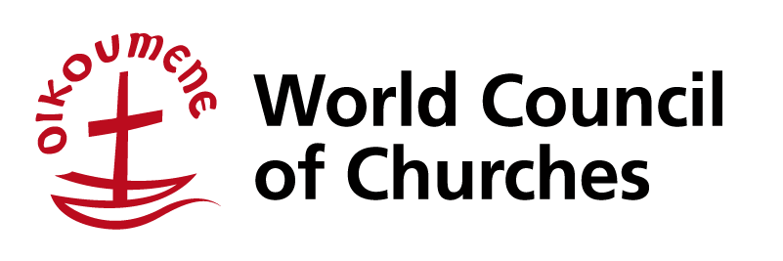

**WCC-PIEF Meeting**

**Abrahams Herberge – Beit Jala**

**March 12-15, 2014**

**Agenda – Draft (2)**

**Wednesday 12th March**Arrivals

17:00-19:00 Getting acquainted

19:00 Dinner

20:30 Review of agenda, introductions, and orientation to the meeting

**13th March**

09:00-09:30 Prayer and Biblical meditation (H.G. Bishop Munib Younan)

09:30-11:30 “Situation Analysis” (Focus on status of peace talks, developments in the region and their impact on P/I)

The “Framework agreement”

(Dr. Mahdi Abdel-Hadi, Director, PASSIA)

General discussions

11:30-12:00 Coffee Break

12:00-13:00 Highlights of:

Church-related actions during 2013 and activities/input in Busan

Kairos Palestine

ACT Palestine Forum

CROs in Palestine

JIC and EAPPI

13:00-15:00 Lunch

15:00-16:30 Highlight session continues

Critical remarks and evaluation

16:30-17:00 Coffee break

17:00-19:30 BDS and the Palestinian civil society

Report from the BDS working group and discussion BDS strategies

WWPPI 2013, and plans for 2014

20:00 Dinner

**14th March**

09:00-09:30 Prayer and Biblical meditation (Rev. Fr Jamal Khader)

09:30-11:30 Reflection and discussion on the WCC focus on “Pilgrimage for Justice and  
Peace"; its implications for renewed PIEF strategy and its interaction with the “Pilgrimages for Transformation”

11:30-12:00 Coffee Break

12:00-13:00 Strengthening the PIEF network - locally and internationally

Openness to other partners (churches/NGOs, etc.)

Future plans

13:00-15:00 Lunch

15:00-16:30 Session on future plans continues

16:30-17:00 Coffee break

17:00-18:30 Conclusions

Next meeting

Other business

20:00 Dinner

**15th March**

Departures